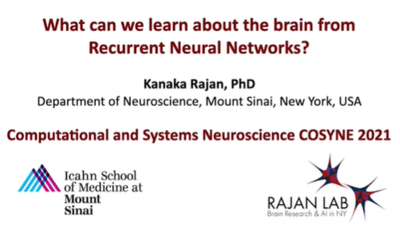

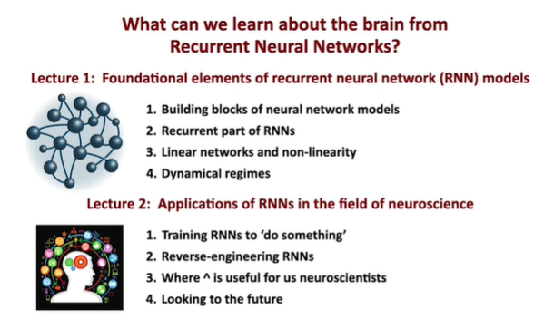

In lecture one, I’m going to be giving you ***an intuition for what the fundamental or foundational elements*** are that go into building recurrent neural network models.

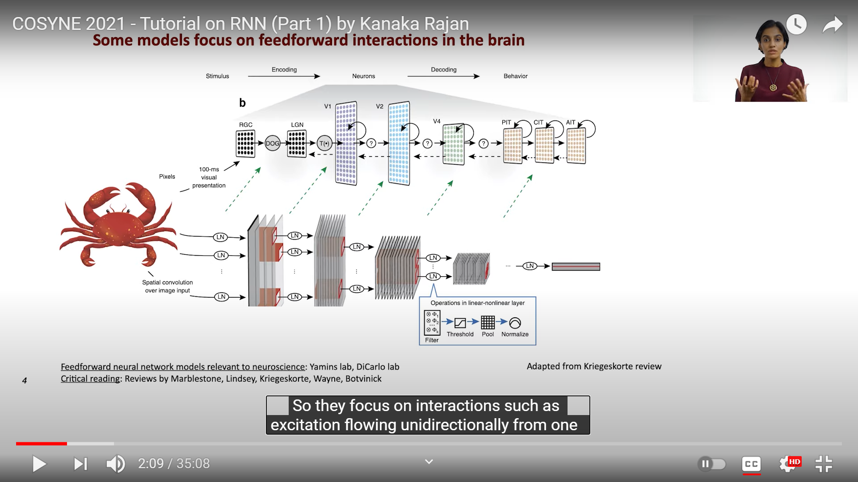

There are many models that look at feedforward interactions in the brain. They focus on interactions such as excitation flowing unidirectionally from one active brain region to the other or in a layer manner.

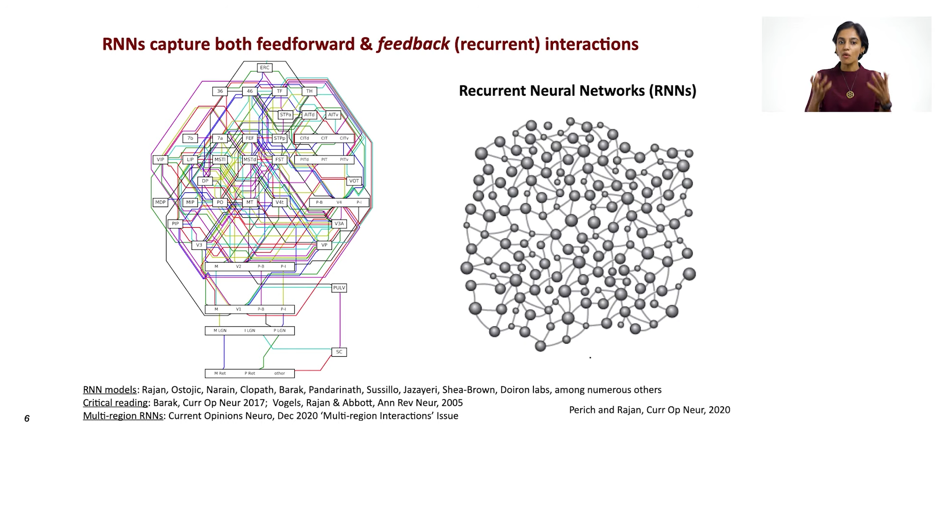

The key feature of these internally generated dynamics is that they come both feedback and feedforward interactions, or in other words, recurrent neural dynamics. ***RNN capture both feedforward and feedback interactions***.

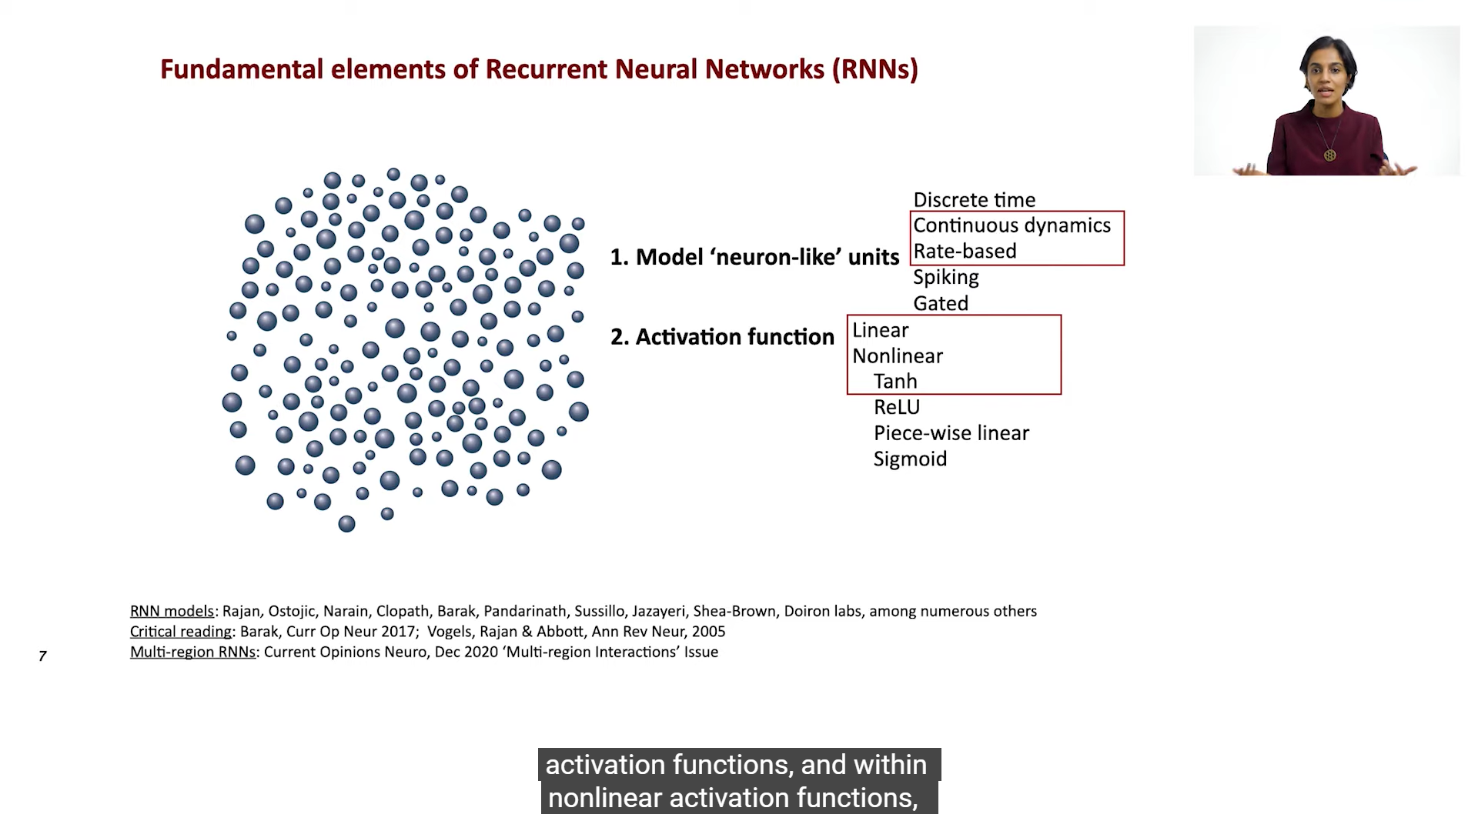

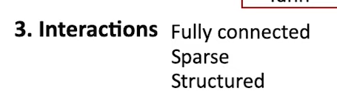

The third element is interactions, they can be fully connected, they can be sparse, and they can also be structured. ***Brent Oren*** has done some beautiful work on structured networks.

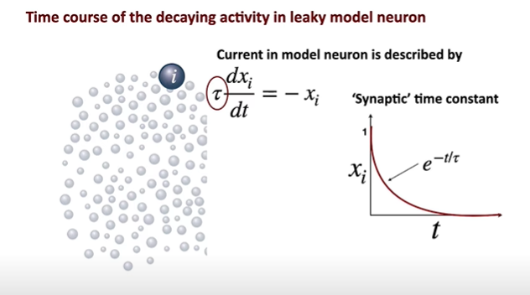

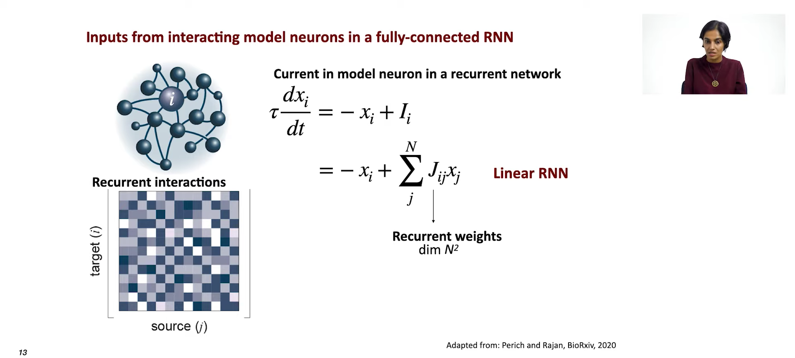

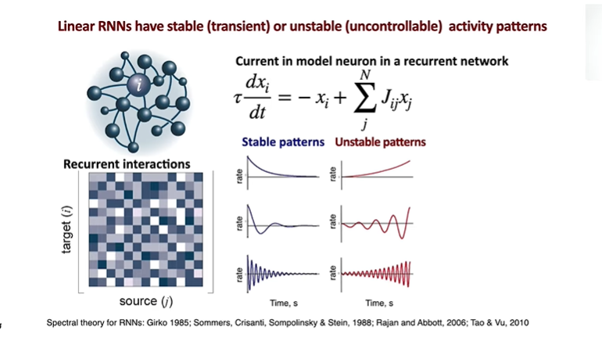

Linear RNNS have stable or unstable activity patterns, stable patterns are all transient, and they all go to a trivial fixed point. The unstable ones are uncontrollable. Except with extreme fine tuning, you can’t get any other behavior from linear recurrent neural networks.

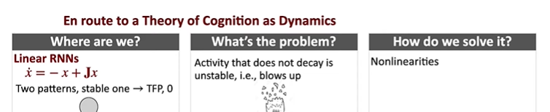

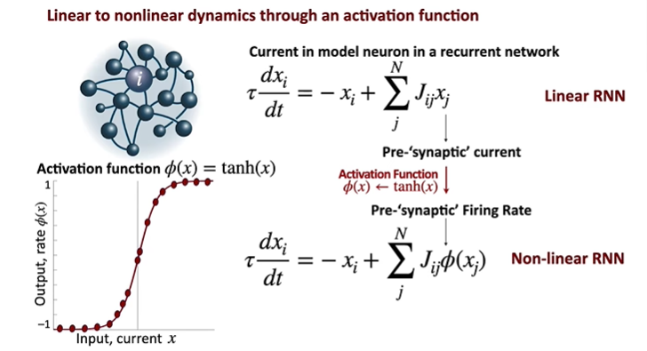

The input to linear recurrent network changed from pre-synaptic current to pre-synaptic firing rate, when currents are stronger, the nonlinearity keeps this network from exploding.

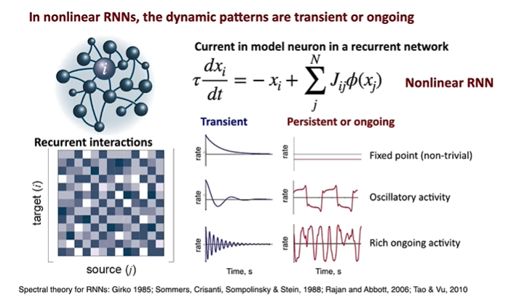

In nonlinear RNNs, the dynamic patterns, rather than being trivial or exploding, become transient or ongoing.

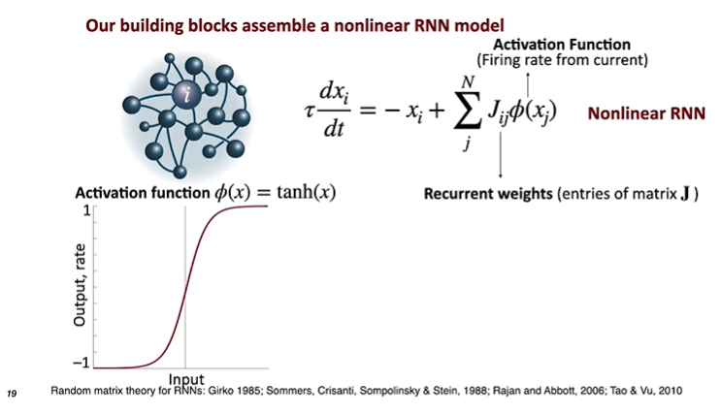

It turns out that ***the key thing to understand*** how networks like this will behave, is looking at the properties of these current weights or the entries of this connectivity matrix J.

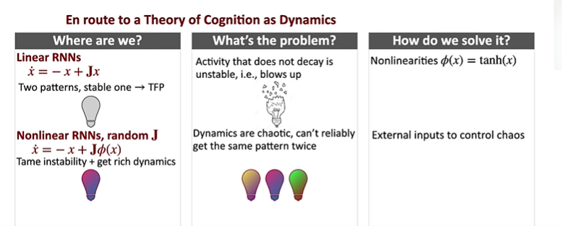

Introduce nonlinearities to linear RNNs bringing RNNs with rich dynamics, the problem for now is that the dynamics are chaotic, can’t reliably get the same pattern twice, what should we do to this model if we want to train them to do some task-specific problems. On route to it, apply external inputs to see if we can get it under control.

Input can be periodic, noisy, naturalistic. Below periodic inputs are used for their mathematical tractability.

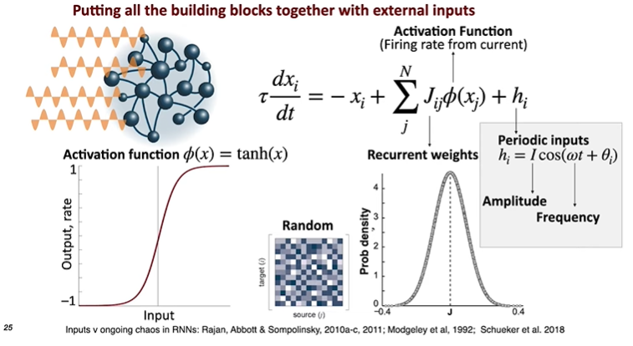

Every unit in the model is going to get the same exact input, with the same amplitude and frequency, with different phase.

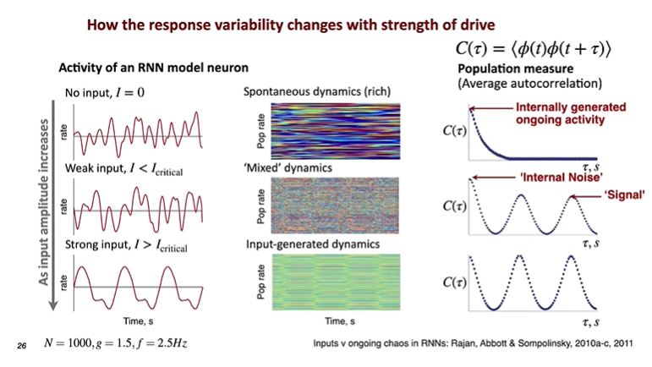

The internal noise here is the memory of this RNN network (RNN J matrix).

